Dil Bechara: A Justice to the First Impression

A cautious start with the **World’s Shortest and the Smallest Heart-Breaking story, “Once upon a time, there lived a prince and a princess. They died, and the story ended!”**. ‘Dil Bechara’ is an un-fairy tale love story that ends with a tragedy. But leaves you with a bounded moral from it. It may seem an ordinary love story but it is not. It is rife and plentiful with emotions that make you laugh, cry, and hope as well.

﻿

**“Do you remember this same story is narrated by the antagonist of the film, "Raabtaa" starring once again, Sushant Singh Rajput opposite Kriti Sanon?”**

RAABTAA (2017)

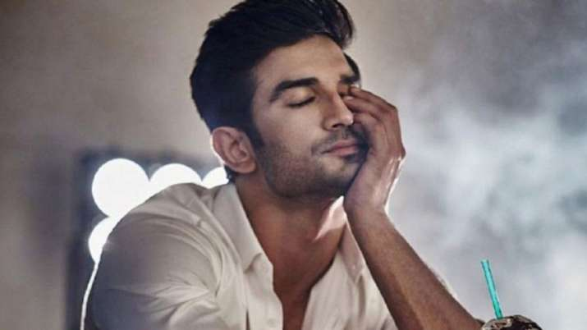

*remembering Sushant in his film, "Dil Bechara"*

**The "Dil Bechara" theory...**

The irony lies in the bookend where the subject of the tragedy is death. Now the irony matches the demise in the reality of late actor [**Sushant Singh Rajput**](https://thinknsay.in/sonalimahapatra/sushant-singh-rajput-a-man-of-reality/)**.** This not only forces you to sob the death of the characters in the end but also to the death of the late actor in reality. The film gets streamed on the OTT platform of **Disney Hotstar on July 24th, 2020.**

Mukesh Chhabra, a well-known Bollywood Casting Director now turning to instruct his first film, “**Dil Bechara**” as a Director. Once narrated in the interview how Sushant Singh Rajput immediately signed the contract to this film even without a second minute thought. This fact portrays his personality that he wasn’t just energetic and charming with his personality over the silver screens, but his innocence that marks a place for him in all our hearts.

**Poisonous factors:**

**Many unpleasant rumours exposed to be that of those psychotic fans who prompt to not watch the film as it reminds them to the late actor.** But my opinion says that if the late actor’s haters think ill of his talent then being a psychotic fan, you are not less than a culprit. I wholeheartedly advise all of you to watch the film in any way possible as to pay a huge tribute to the dynamic actor.

**Another rumour gets revealed about the film that is a pirated version of** [**John Greene’s 2012 best selling novel, “Fault In Our**](https://en.wikipedia.org/wiki/The_Fault_in_Our_Stars) Stars.” It is true that the film is an adaptation from this best-selling book, but legally. It has been transfigured paying back a good sum of money to the creator of the novel legally for adapting the story. And thus, it nowhere marks the image of disloyalty.

**Master of Emotions!**

Speaking truth, I personally haven’t read the original book and did not watch the American movie version either. After watching the Dil Bechara trailer, it is all of a sudden, I came to knew that the film is based on a famous novel. I was eager to watch the 2014 film, but then I felt like watching for the first time in Dil Bechara itself. It may be the story, the characters. I wanted to feel all the emotions of the story in “Dil Bechara” itself. And in my own view, I affirm the fact that when it comes to delivering emotions, one cannot compete with Indian Cinema. Indian Cinema is the Mother of language and emotions, and representing this story in Indian Cinema, it is obvious that I will be literally sobbing at the end of the movie, so as you. You can trust me.

**Manny and Kizzie**

Keeping the story aside for a while, let's talk about the enthusiastic characters played by Sushant Singh Rajput and Sanjana Sanghi as Manny and Kizzie subsequently. Sushant’s character is a ray of sunshine, playful, a full of life character whereas that of Sanjana’s is more into a constrain, world-closed-up one. None of us has watched this film yet, but hints adopted from the trailer speaks a lot. Trailers are made to appear a film impressive and exciting. No big deal if you already watch the 2014 film or read the novel, but this Indian Film is going to speak a lot more than the trailer of the American version. Just from trailers, the representation of Manny and Kizzie has a huge part of the fact that the acting looks so real. I admit it.

**Cast and crew:**

Surprisingly, **Saif Ali Khan** is in the film in the role of Abhimanyu Veer. I can be sure only a few of you might be knowing this. There is no idea what type of role he plays, but he is quite efficient enough to make us feel he must be doing good. The other supporting actors include Swastika Mukherjee as the mother to Kizzie Basu; and many more. It is currently only a conscience that makes me feel they are one of the amazing and valuable actors too who play balance the story in an efficient way without losing their identity.

**Sushant as Manny:**

Every film of Sushant inspires people of all ages leaving a moral behind, and the same goes with Dil Bechara. The widespread smile is not an ability of Manny but of Sushant. It is real. It feels like his tragedy did not happen in real life. He is still out there somewhere in his house, living happily, enjoying life as he should be enjoying. His cheerfulness and full of life kind of behavior can make us smile and feel sad at the same time. I am sure nobody would have ever thought of feeling that way after watching the trailer and later the movie.

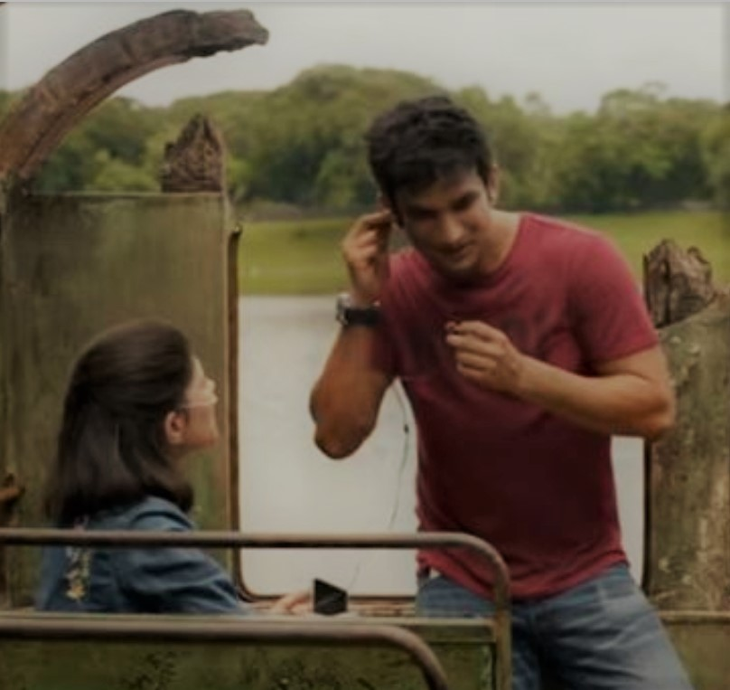

*A solitude cheerful conversation between Manny and Kizzie in an inhabited broken double-decker bus.*

The movie is full of packages with all types of emotions you can find in it. It can make you cry, happy, smile, laugh, pity, fear, and angry over fate, and of course make you fall in love. Moreover, the crew of the film is not left behind. Produced under Fox Star Studious, distributed by Disney Hotstar, and directed under the guidance of Mukesh Chhabra, the film itself in more than is common. Music directed by A. R. Rahman it is going to touch your souls forever and you won't back off it so soon.

**Conclusion:**

Dil Bechara is way more bitter than it is sweet on the bittersweet side effects. It is stringed with pounds of emotions making you feel the love in reality. Any broken love out there is sure to feel the film energizing him or her to never lose hope on love.

**Attention!** - Before concluding my assessment of “Dil Bechara”, I would like to leave you with a short question- **“Did you notice the word HELP! imprinted on Manny’s T-shirt at the end of the trailer?”** If yes, then comment down below and let me know what do you think about it.

